Name Date
Practice A
8.2
Find the area of the entire surface of the prism.

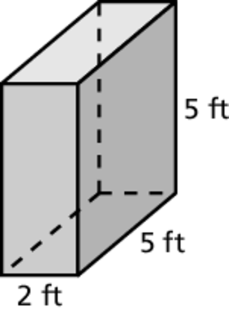
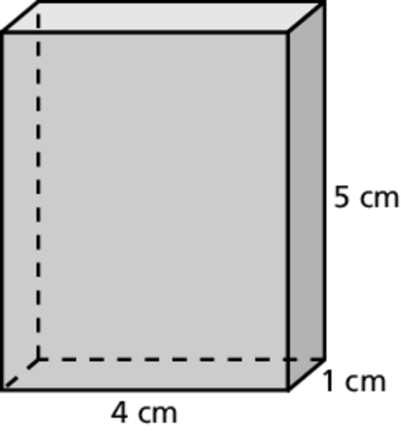
1. 2.
Front: Front:
Back: Back:
Left: Left:
Right: Right:
Top: Top:
Bottom: Bottom:

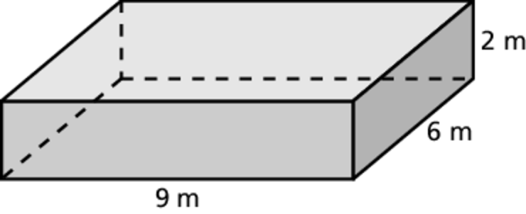
3.
Front:
Back:
Left:
Right:
Top:
Bottom:

